Graph Practise

Use Excel to help answer the following questions. Remember to make sure your axis are clear and your graph makes sense. Remember to label everything.

Question 1:
In an experiment on Charles’s law, the value of the volume of gas, V m3, was measured for various temperatures T ◦C. Results are shown below.

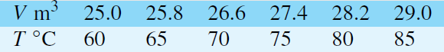

Plot a graph of volume (vertical) against temperature (horizontal) and from it find
(a) the temperature when the volume is 28.6m³
(b) the volume when the temperature is 67◦C

Question 2:
In an experiment demonstrating Hooke’s law, the strain in an aluminium wire was measured for various stresses. The results were:

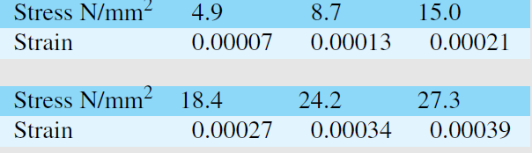

Plot a graph of stress (vertically) against strain (horizontally). Find:
(a) Young’s Modulus of Elasticity for aluminium which is given by the gradient of the graph
(b) the value of the strain at a stress of 20 N/mm²
(c) the value of the stress when the strain is 0.00020

Question 3
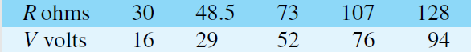
The following values of resistance R ohms and corresponding voltage V volts.

Choose suitable scales and plot a graph with R representing the vertical axis and V the horizontal axis. Determine
(a) the gradient of the graph
(b) the R axis intercept value
(c) the equation of the graph
(d) the value of resistance when the voltage is 60 V
(e) the value of the voltage when the resistance is 40 ohms.
(f) If the graph were to continue in the same manner, what value of resistance would be obtained at 110V?
Question 4
Experimental tests to determine the breaking stress σ of rolled copper at various temperatures t gave the following results.
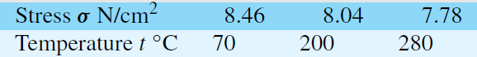

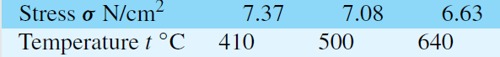

Show that the values obey the law σ =at +b, where a and b are constants and determine approximate values for a and b. Use the law to determine the stress at 250◦C and the temperature when the stress is 7.54 N/cm²

